RECEIVER HITCH
Application
2007-15 IQ/TOURING HITCH/TURBO/600 LXT

IMPORTANT: We highly recommends that the installation be performed by a certified technician.

Before you begin, read these instructions and check to be sure all parts and tools are included
Please keep these instructions for future reference.
This kit includes:
Qty |  | Part Description |  | OEM reference
1 |  | Weld Hitch Black |  | 1014685-067
4 |  | Rivet |  | 7621418
10 |  | Rivet |  | 7661637
1 |  | Instructions |  | 9920810

You will need to Supply:
Drill and #7 or 13/64" drill bit 1/8” Punch Ratchet and 7/16” socket
Rivet gun Torx T-20

IMPORTANT : For your safety, and to ensure a satisfactory installation, perform all installation steps correctly in the sequence as shown on the attached instructions.

INSTALLATION INSTRUCTIONS
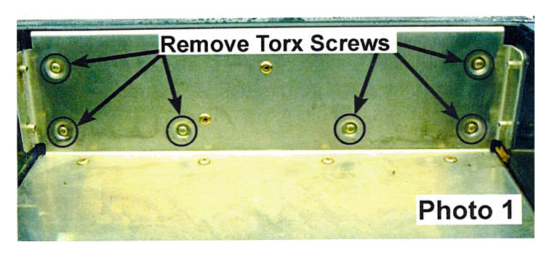

1. Remove taillight housing by removing six Torx
screws from inside rear wall of trunk area.
Remove two push-on fastener clips from under
the taillight assembly, one from each side.
Carefully disconnect wire harness from taillight
in two places.

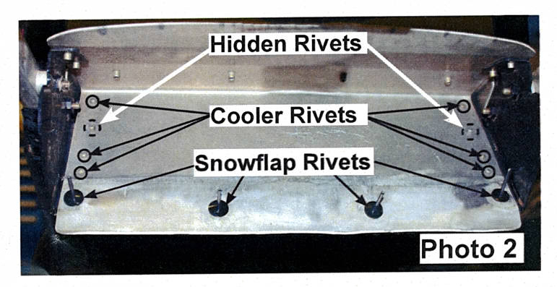

2. Using a 1/8" punch, tap out all the snow flap
rivet nails. Drill and remove four rivets holding
snow flap onto black bracket and rear close off
panel. (Photo 2)

3. Using a 1/8” punch, tap out the six accessible
cooler rivet nails holding cooler onto tunnel
extension. (Photo 2)

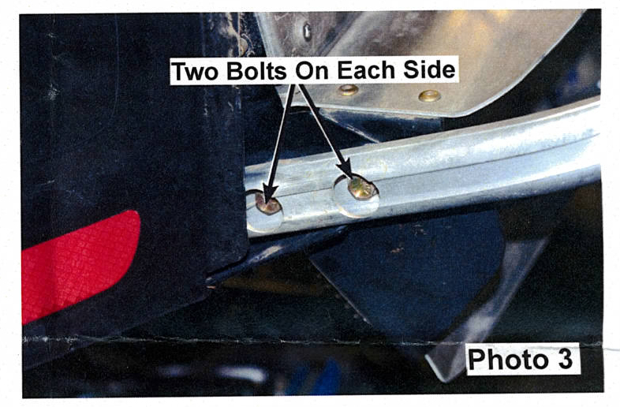
4. Remove the four bolts, two on each side,
holding bracket to bumper using ratchet and
socket. (Photo 3)

5. Cooler should now be attached only by hoses
at each end. Swing cooler down out of the way
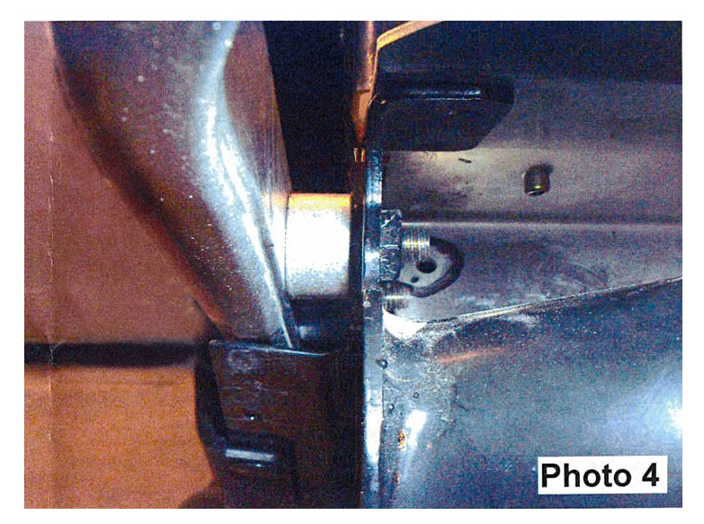
to access the remaining two rivets holding the
bracket to tunnel extension. Drill and remove
these two rivets.

6. Drill and remove four rivets holding brackets to
top of tunnel extension. Brackets should now be
able to be removed from machine. Do not re-use
these brackets. (Photo 4)

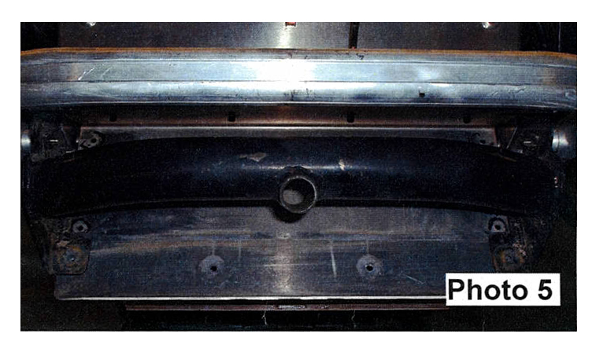
7. Position hitch in location where brackets were
removed, making sure receiver is on bottom side
of bar connecting brackets. Install four bolts
through bumper side and into hitch side plates.
Torque to 10 ft. lbs. (Photo 5)

8. Install rivets and bolts in opposite order they were
removed. Align holes at each step before installing
rivets to ease installation. Reinstall bumper using
original hardware and torque to 10 ft. lb.

9. Attach wire harness connections to taillight
assembly. Reinstall taillight assembly and tighten
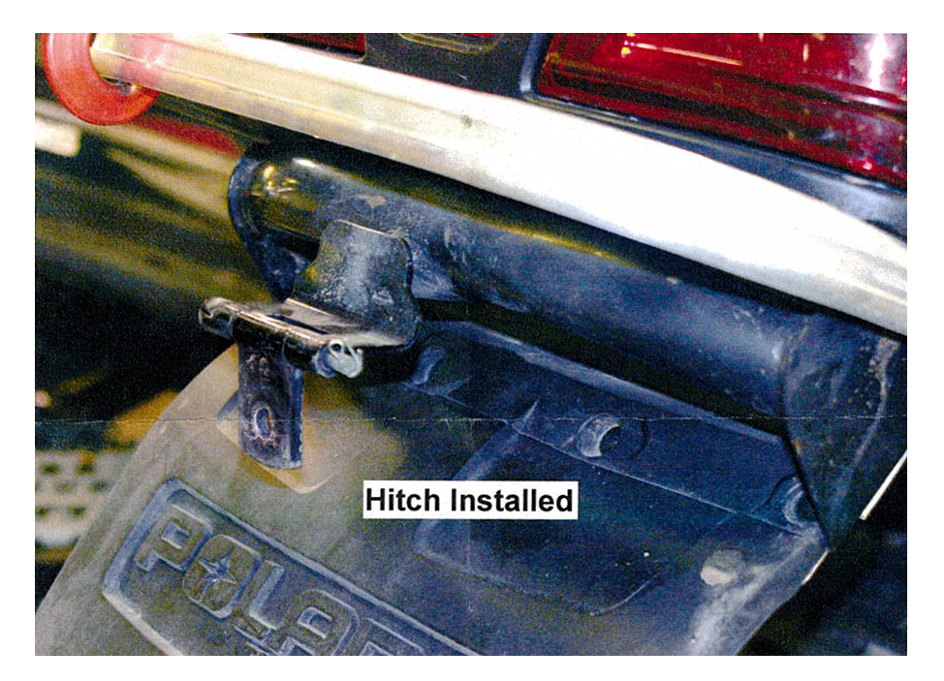
screws to 12 in. lb.

DISCLAIMER: This item is sold without any expressed or implied warranty of merchantability or fitness for a particular purpose. The Manufacturer, Distributor, nor Dealer shall be held liable for any special, incidental, or consequential damages, including damage, loss of revenue, cost purchased or use of this product.

